An Investigation of Additive Manufacturing Technologies for Development of End-Use Components: A Case Study

Vahid Hassani

Sustainable Advanced Manufacturing (SAM), University of Sunderland,
vahid.hassani@sunderland.ac.uk
Vahid Hassani, https://orcid.org/0000-0001-6724-2520

ABSTRACT
Prior research has shown that additive manufacturing (AM) can be used to make functional and end-use components, however the absence of design guide has led to restricted use of AM in industry. This research aims to redesign a pressure reducer valve integrated into an end-cap as a subcomponent of composite pressure vessel (CPV), which is manufactured by AM. First, a number of design criteria are defined based on the shortcomings of the current pressure reducers manufactured by conventional methods. Then the design procedure is pursued by several iterations using material jetting, material extrusion, and powder bed fusion which are known as commonly used methods of AM. Through this research, the design imperfections and experiences are identified in terms of lessons learned, design rules and an overall design procedure is established.

Introduction
In recent years, AM has attracted much attentions from researchers and manufacturers to redesign and modify the current industrial products concerning the unique design freedoms which are offered by it. The unique capabilities of AM enable for more customized products in terms of development of parts with higher complexity in shape, material and functionality [1, 2]. In the past decade, AM was mostly used as a building platform for prototyping [3,4], whereas its usage has been recently extended to industrial applications such as medical industries [5-10], aerospace industries [11-16] and etc. This occurs not only because of the technology and market growth [17] in this field, but also because of several advantages offered by this method in comparison with the conventional manufacturing. Amid the highlighted advantages, increasing the production volume, decreasing the costs and weights of the products can be enumerated. However, due to the absence of sufficient standards and guidelines in different methods of AM, researchers and industrial partners have only limited application of this method as an efficient manufacturing platform. In order to respond to the needs, some design rules have been developed and published for some particular methods of AM such as laser sintering (LS) [18,19], laser melting (LM) [20,21] and also material jetting [22]. In this line of research, a worksheet was designed by Booth et al. [23] to address the common mistakes made by the designers to redesign the components and parts by AM. More broadly, design for AM (DfAM) methods have been developed considering the AM capabilities [24] to establish design rules with regards to manufacturing process constraints [25]. Furthermore, some jobs were investigated in terms of design process, conceptual design, embodiment design, detail design and process selection to create a framework of mapping design for AM [26].

Currently, CPV designs have shortcomings resulting from the lack of integration of the pressure vessel structure and the pressure regulators. Both are typically made by different manufacturers with different design and manufacturing principles. This leads to disadvantages, such as non-optimized structures and protruding regulator assemblies, resulting in additional weight, packaging issues and safety concerns. Those design have been around for many years, since improvement is difficult when keeping conventional manufacturing methods. Despite the Composite structures are superior for extended structures and simple load case scenarios [27], where directed fiber optimizations can be thoroughly explored, they are difficult to be used for building complex components, because of the inherent design and manufacturing restrictions. On the flip side, AM enables for development of complex components, manufacture of inner structures, design integration and customization, but usually there are spatial constraints which are comprehensively investigated in [28]. Regarding the manufacturing process, composite manufacturing is becoming more automated, which is somewhat similar to AM [29, 30]. Therefore, the combination of both technologies i.e., composites and AM, promises enormous potential, if experience in the integrated design is developed and design guidelines are established. This research will present a redesigning process in terms of an industrial example in order to explore and evaluate the unique capabilities of polymer-based AM processes in redesigning the end-use parts which are compatible with CPVs. In result, Lessons learned, design guidelines, and a design procedure will be the main outcomes of this research in addition to development of an AM product that can be used as an integrated part of the basic composite part i.e., CPV.

This paper is organized as follows. In Section 2, some shortcomings of existing pressure reducers are considered and the proposed solutions for those limitations are defined in terms of the design instructions in Section 3. Afterward, the design procedure and development of the integrated pressure reducer end-cap will be discussed on the continuation of the design instructions in Section 3 by defining the inherent constraints existing in the design process. Section 4 will describe the design rules of the integrated pressure reducer end-cap and Finally, Section 5 will conclude the paper.

Shortcomings of the Current Pressure Reducers

This research aims to investigate the potential capabilities of AM technology on integrating a pressure reducer into an end-cap, which is installed on top of CPVs. Currently, CPVs and pressure reducers are mostly manufactured by different manufacturers which results in a lack of integration of two parts. This leads to some disadvantages that will be considered in this section in order to define the design instructions for an integrated pressure reducer end-cap. The main disadvantages of the current pressure reducers are discussed as follows:

2.1 Protruding Head Assembly

As shown in Figure 1, reducer assemblies protrude out from the end of pressure vessels. One consequence is that the resulting assembly has additional weight compared to more integrated designs. Since the current reducer assembly is made of dense materials such as titanium and steel alloys, it will impose extra weight to the entire structure of CPVs.

The next disadvantage of the protruding head is to bring difficulties in packaging. Protruding reducer assemblies will claim more space due to the excessive length. As a result, the number of CPV units that can be loaded per unit of volume will decrease, respectively.

In addition to the limitations mentioned above, another important issue is the lack of safety with this configuration for the head assembly. During loading and unloading of CPV units, and more broadly during the normal operation of the system, if the head assembly is suddenly broken due to poor bonding of the head to CPV or any unpredictable reasons, it may cause irreparable consequences either for the human operators/users or for the operating system.
Figure 1. Protruding Head Assemblies

2.2 Non-Optimized Structure

As discussed earlier, CPVs and pressure reducers are mostly manufactured separately by two different manufacturers. CPV manufacturers will order a pressure reducer based on its operational need and assemble it to the intended port of the CPV. Alternatively, an integrated design could be pursued where the pressure reducer is integrated into the end-cap of the cylindrical CPV shown in Figure 2. This design configuration will allow us to investigate the structure of CPV together with end-cap in an integrated manner and optimize the size and geometry of the end-cap based on the desired structural objectives.

a)
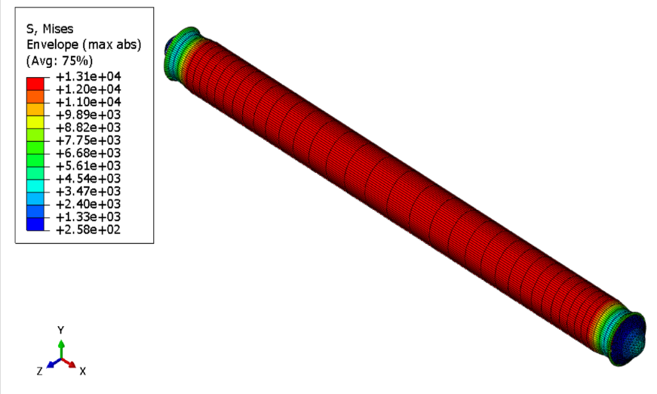

b)

Figure 2. a) Integrated End-Cap and CPV, b) Structural Analysis of End-Cap and CPV

Design and Manufacture of Integrated Pressure Reducer End-Cap

Understanding the shortcomings of the conventional design discussed in 2.1 and 2.2 will assist us to design and develop an integrated pressure reducer end-cap by using the most recent manufacturing method i.e. AM technologies. This technology offers advantages to develop complicated and integrated inner structures where the shape complexity is rectified without extra cost and process that are imposed by conventional manufacturing methods.

3.1 Design Instructions

Merging the disadvantages of the current pressure reducers and the advantages of AM technologies, the following design instructions can be defined for the proposed integrated pressure reducer end-cap.

3.1.1 Structurally-Optimized End-Cap

The design procedure is initiated with a specific pressure vessel and its construction, that are shown in Figure 3, consisting of the pressure vessel body, end-caps at both ends, and an internal liner in a non-optimized end-cap structure with specific dimension.

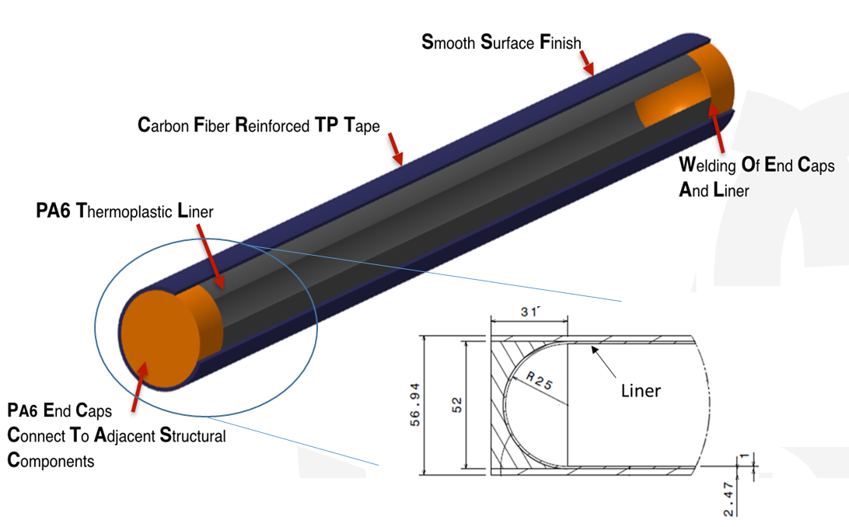

Figure 3. Initial Integrated End-Cap and CPV (Dimensions in Millimeter)
The end-cap is separately shown at bottom right of Figure 3. The overall thickness of material above the zenith of inner hemisphere to the top of the end-cap has to be obtained with regards to FEM analysis. The final optimized structure must be able to withstand the desired burst pressure without any plastic deformation of the internal cavities and external surfaces.

3.1.2 Inner Cavities and Structures

In order to avoid the protruding pressure reducer assemblies, all cavities for placing the accessories and inner pipelines between cavities have to be designed and manufactured inside the end-cap which houses the pressure reducer assembly and plays as a connector of CPV to pressure reducer as well. The external cylindrical surface of the end-cap should be free of protrusions to facilitate the filament winding process.

3.2 Design Procedure of the Integrated Pressure Reducer End-Cap

Applying the design instructions, this section aims to describe a design procedure for an integrated pressure reducer end-cap by AM, which offers the possibility to design and manufacture complex internal geometry and simultaneously integrate the reducer, a methodology known as functional integration. The specific design challenge is to integrate the pressure reducer into the end-cap, using the end-cap body as the housing for the reducer. That is helpful, before going to the main core of design process, one must understand the function of pressure reducer at the first step.

3.2.1 How does a Pressure Reducer Operate?
The key elements of a typical pressure reducer and their functions are shown and discussed here. As illustrated in Figure 4, a pressure reducer consists of three key elements namely, loading spring, diaphragm and poppet.

a) b)
Figure 4. Key Elements of Pressure Reducer: a) Closed Position F_{S}<F, b) Open Position F_{S}>F
As long as the force is not applied to the loading spring, the diaphragm and the poppet are in statically balanced condition and no output pressure is generated as shown in Figure 4a. Once the input force is applied to the loading spring, the whole assembly including the diaphragm and the poppet are moved down to the open position (see Figure 4b). The air from the pressure vessel passes through the poppet and comes to the diaphragm chamber. Depending on the stiffness of the loading spring and diaphragm, the output pressure is generated and the excessive pressure above the design limit will move the loading spring and the diaphragm upward to close the passage of air through the poppet. After the trapped air is discharged from the diaphragm chamber, the diaphragm and the loading spring returns the poppet to the open position. This frequent closing and opening actions of the poppet is so-called pressure regulation.

Understanding the function of regulation will assist us have an approximate estimation to design a suitable cavity inside the end-cap for placing the key elements of the pressure reducer. Using the knowledge achieved from the initial geometry of the end-cap in Figure 3, the first configuration of the integrated pressure reducer is proposed like as illustrated in Figure 5. Unlike the conventional pressure reducers that have vertical arrangement of the elements, the new design accommodates the elements horizontally into the end-cap.

3.2.2 Additive Manufacture of the Integrated Pressure Reducer End-Cap
Much of the technical work focused on designing a pressure reducer that was integrated into an end-cap in order to avoid the protruding pressure reducer. One of the first designs to be developed is shown in Figure 5 and consists of single pressure reducing valve stage.

Figure 5. Schematic Diagram of the First Prototype of the Integrated Pressure Reducer End-Cap
According to the dimensions of end-cap given in Figure 3, the maximum solid section of the end-cap, or in other words the maximum space on top of the zenith of hemisphere is allocated to build a cavity in order to accommodate the elements of the pressure reducer.

For 3d-printing of the first prototype, four different machines were dedicated. The Stratasys J750-2 polyjet machine is used for material jetting of the Vero (hard polymer) and Tango (soft polymer) or combination of both with the desired percentage from each of them, Stratasys Fortus 450 MC is used for printing of the part with PA12, the EOS Formiga selective laser sintering machine is used with PA12 powder and the fourth machine is the Markforged machine for printing of the part with combination of PA12 and carbon fiber layers. Figure 6 shows the image of the part with regulator elements inside it and Figure 7 shows the parts printed with the different 3d-printers mentioned above.

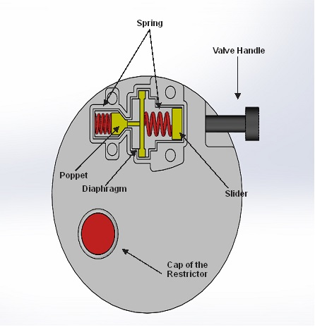

Figure 6. Integrated Pressure Reducer End-Cap with Regulator Elements Inside the Cavity
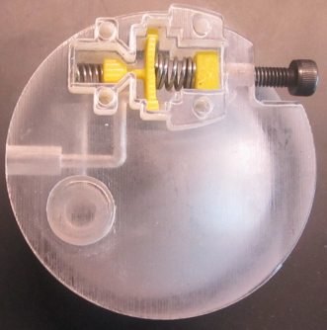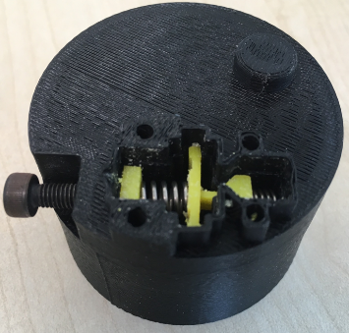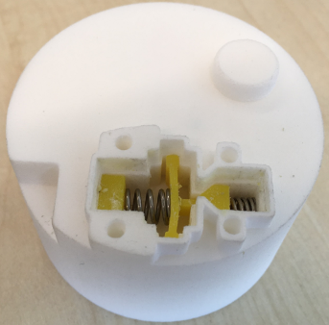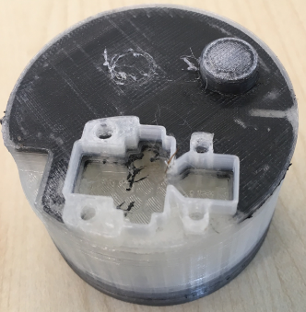
a) b) c) d)

Figure 7. Different 3d-Printed Parts; a) Material Jetting Polyjet J750-2 Vero Clear, b) FDM Fortus 450 MC PA12, c) EOS Formiga PA12, d) FDM Markforged PA12 and Carbon Fiber
As shown in Figure 7, several versions were fabricated in the Stratasys J750 (a), Stratasys Fortus 450mc (b), EOS Formiga (c), and Markforged Mark 2 (d) printers to explore the capabilities of various fabrication processes. End-caps from the J750 and Formiga were of highest quality. The material used in the Formiga was polyamide 12 (PA12), which is the same family of thermoplastics used as the matrix material in the CPVs to be fabricated. Hence, PA12 end-caps fabricated in the Formiga were selected for usage in the project demonstration CPV. However, the J750 was easy to use and resulted in transparent end-caps that enabled visualization of internal features, so it was used to fabricate many end-cap prototypes.

3.3 Constraints Investigation in Design Process
The most important design constraints that should be taken into account during the design process of integrated pressure reducer end-cap are discussed as follows:

3.3.1 Geometry. The design procedure was started in a non-optimized structure end-cap with a limited solid space above the zenith of hemisphere. Consequently, the cavity had to be designed such that it is able to accommodate the elements of the pressure reducer as well as using the solid space of the end-cap optimally. In other words, the initial proposed geometry does not allow us to implement the vertical concept for arrangement of the pressure regulator elements. This is why the horizontal concept is substituted at the first stage of the design as illustrated in figures 6 and 7.

3.3.2 AM Technologies. In general AM framework, designers must consider many types of constraints involved with AM process and creates some problems in final product. One of the main issues that should be taken into account is the accuracy of the process to fulfill the tolerances in the final part. Since the elements of the pressure reducer are placed in the cavity, tolerances play an important role. All interacted parts which are placed into the cavity should have the same dimension and angle of the printed cavity. If the tolerance between the interacting parts and the cavity is maintained small enough, the proper operation of the valve will be guaranteed, otherwise some malfunction will occur during the operation.

As is well known, some AM processes require the use of support structures, specifically the FDM and Polyjet processes used in this project. Support structures are used to support bottom surfaces, overhangs, and internal cavities and channels (pipes, pipelines). It is very important that the designer consider supports during part design [31]. The role of support generation and support removal has equal importance during the additive and subtractive processes. As a matter of fact, the support has to be generated to ensure that the part is properly printed without any deformation, but the generated support must be removed in the subtractive process either using liquid solvents, manually or by special machining tools. The common method for support removal of the FDM and Polyjet 3d-printed parts is to use solvents in an ultrasonic bath. Note should be taken that the support removal will start from the external sections and will continue and end at the internal sections.

3.3.3 Structural Stability. From the structural point of view, as discussed earlier, the proposed end-cap has non-optimized structural shape. To obtain the optimal dimension of the end-cap in terms of maximum structural strength at maximum burst pressure, a FE analysis is performed using a commercial finite element software, ANSYS. For this purpose, the mechanical properties of two dog-bone specimens made of FDM PA12 and SLS PA12 are measured using an INSTRON test platform. The results of the test are displayed in Figure 8. Using the mechanical properties of FDM and SLS parts, two separate analysis were performed for the non-optimized and the optimized geometries of the end-cap.

a)
b)
Figure 8. Results for Tensile Test; a) FDM-PA12, b) SLS-PA12
Figure 9 shows the nonlinear FE analysis of the initial end-cap, which is manufactured by FDM 3d-printer and PA12 filament. The area around the end-cap is considered fixed without any motion as a boundary condition (see Figure 9a). After application of 24MPa at the internal surface of the end-cap, the plastic deformation occurs as shown in Figure 9b.

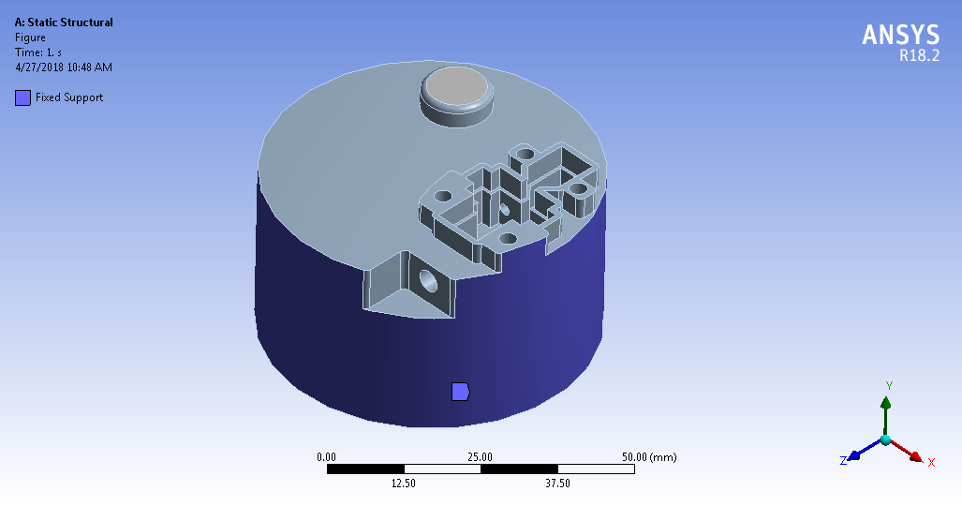
a)
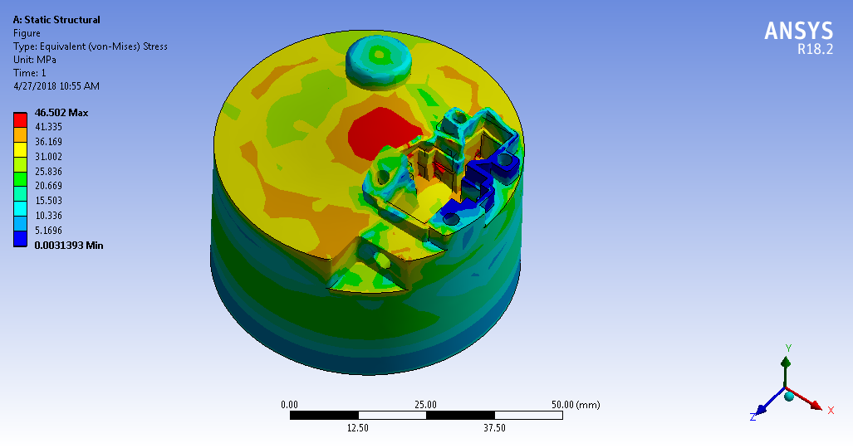
b)
Figure 9. FE Analysis of the Initial End-Cap Printed by FDM-PA12: a) Boundary Condition, b) Failure Simulation after Application of Internal Burst Pressure, 24MPa

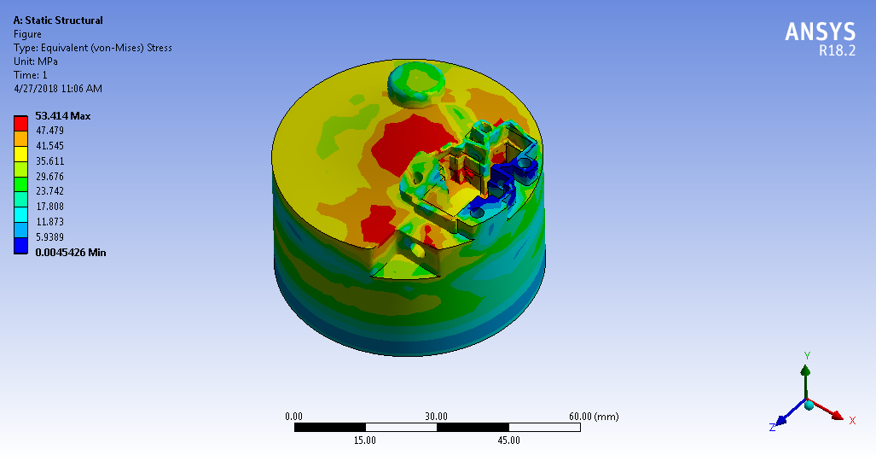
Figure 10. FE Analysis of the Initial End-Cap Printed by SLS-PA12: Failure Simulation after Application of Internal Burst Pressure, 30MPa

Similarly, Figure 10 shows the nonlinear FE analysis of the initial end-cap, which is manufactured by SLS 3d-printer and PA12 powder. The area around the end-cap is considered fixed without any motion as a boundary condition like as shown in Figure 9a. After application of 30MPa at the internal surface of the end-cap, the plastic deformation occurs as shown in Figure 10. The burst pressure increases thank to the higher strength which is obtained using the synthesis laser sintering (SLS) technology in comparison with the Fusion Deposition Melting Technology known as FDM. The results of tensile test also confirm that SLS method will bring higher strength for the part compared to the FDM method.
In order to achieve higher structural strength and the burst pressure above 30Mpa, the optimized structure is proposed with an increase in length between the zenith of hemisphere and the top side of the End-Cap (See Figure 11) of 20 mm. This geometry will result in higher strength and higher burst pressure for both FDM and SLS 3d-printed parts. E.g., the burst pressure for FDM part increases up to 48 MPa and for SLS part increases up to 66 MPa, respectively. These burst pressure will create higher safety margin for the new product. Figures 12 and 13 subsequently show the results of FE simulation of the optimized end-cap for FDM and SLS parts.
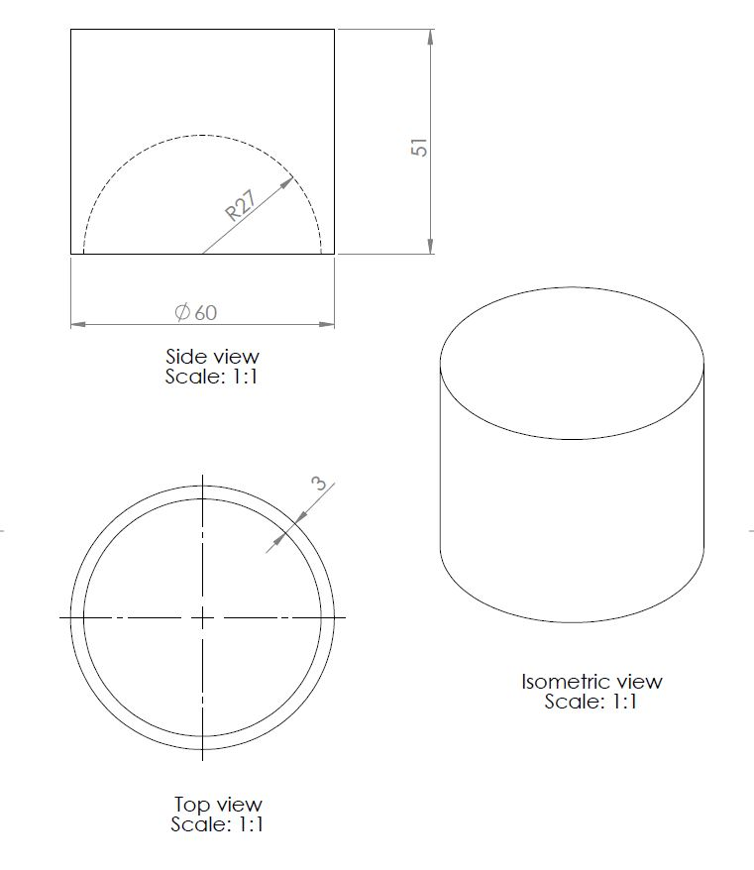
Figure 11. Proposed Optimized End-Cap with Larger Dimensions
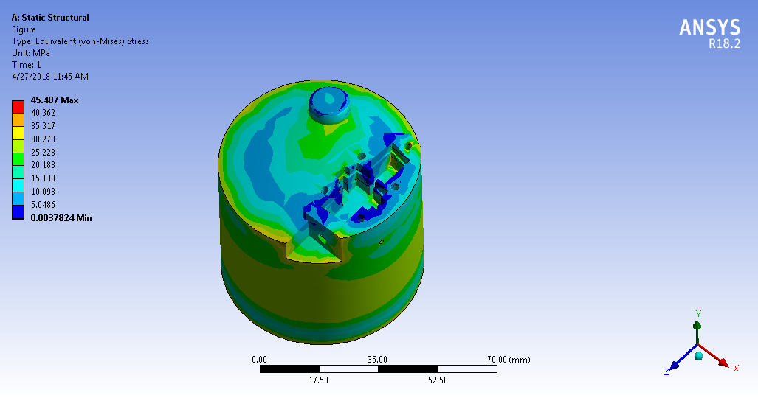
Figure 12. FE Analysis of the Optimized End-Cap Printed by FDM-PA12: Failure Simulation after Application of Internal Burst Pressure, 48MPa
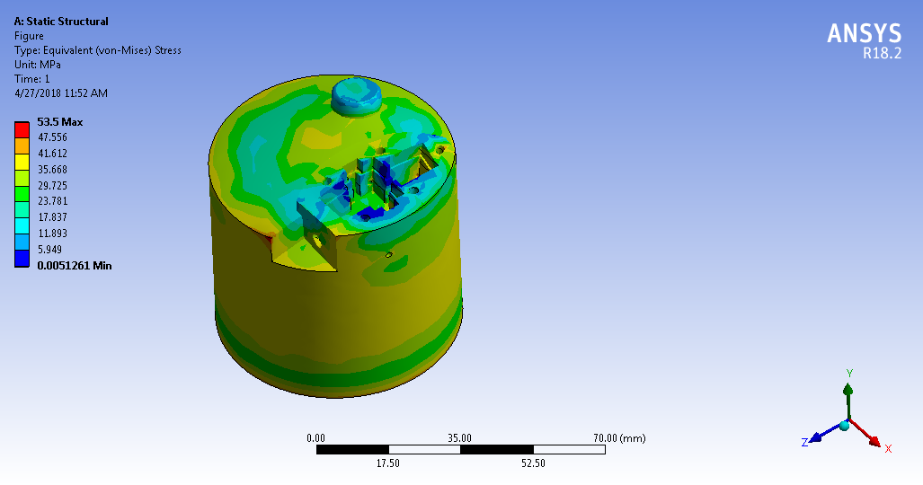
Figure 13. FE Analysis of the Optimized End-Cap Printed by SLS-PA12: Failure Simulation after Application of Internal Burst Pressure, 66MPa
In figures 12 and 13, one can see the maximum von-Mises stress increases with the increase of thickness between the zenith of hemisphere and the top side of the end-cap.

3.3.4 Suitable Sealing Feature against Air Leakage. The most critical stage of the design process is to provide a reliable sealing protection against air leakage. In the initial non-optimized configuration of the end-cap, the cross section of the poppet and diaphragm were chosen squared due to the limited solid space on the upper portion (see Figure 14).
Basically, the poppet is a separator of high pressure chamber from low pressure chamber in front of the diaphragm (see Figure 14). The triangular edge of the poppet seats on the triangular part of the cavity in order to ensure that no leakage occurs from high pressure chamber to low pressure chamber when the system is not in operation.

Figure 14. Different Zones of the Integrated Pressure Reducer End-Cap
From the basic operation of the pressure reducer discussed in Section 3.2.1, the diaphragm is moving against the two surfaces during operation. One of the surfaces is the floor of cavity, while the other one is the lower surface of the cap, which is held on top of it. As a weakness point of the design, no sealing protection (rubber seals/O-rings) can be used to stop the air leakage between these moving surfaces.
To inspect the occurrence of the air leakage in this design, one experimental setup was dedicated as shown in Figure 15. The experiments revealed that the air leakage is inevitable in this configuration.

Figure 15. Experimental Setup: Air Cylinder with Integrated Pressure Reducer End-Cap and Pressure Gauge
In order to resolve the leakage problem, the second configuration of the integrated pressure reducer end-cap is proposed. As shown in Figure 16, two cylindrical cavities are printed inside the end-cap which are connected by a line with small diameter of 2.6mm. Since the cavity is cylindrical, we expect that we can provide sealing protection against air leakage by utilization of different sizes of O-rings inside the circular cross-section of cavities.

Figure 16. Schematic Diagram of the Second Prototype of the Integrated Pressure Reducer End-Cap with its Internal Parts
In this configuration, in the right cylindrical cavity, poppet spring holder is placed that can be seen in Figure 17. Similarly, in the left cylindrical cavity, diaphragm holder is placed as illustrated in the same figure. The holder of the diaphragm is threaded in order to include a screw-handle (see input handle in Figure 17). The screw handle is used for applying the load on the diaphragm-spring and subsequently on the poppet rod (see Figure 17) to open the air passage to the output of the end-cap.
To ensure that there is no air leakage from the right cavity to the left cavity when the system is not in operation, the poppet is equipped with a small poppet O-ring as shown in Figure 17. In addition to the leakage protection between two cavities, we have to make sure that there is no air leakage from two cavities to outside of the end-cap. For this purpose, some slots have been designed on the holders and diaphragm with specific length and depth. These slots can be seen in Figure 17 that are equipped with O-ring against the air leakage.

Figure 17. Integrated Pressure Reducer End-Cap Assembly
As shown in Figure 17, All accessories, including end-cap and its internal cavities and embedded pipe lines, are 3d-printed except O-rings and springs. As seen, the poppet spring holder and the diaphragm holder are screwed to the body of the end-cap to support the poppet spring and diaphragm spring in their places from popping out. Once the input force is applied to the diaphragm spring by turning the input handle, diaphragm is moved to the right and move the poppet rod and poppet, respectively. Depending on the input force applied, the poppet is displaced and open the stand-by air to flow to the diaphragm chamber and subsequently to the output of the pressure reducer. If the applied force to the input handle increases, the opening of the poppet will also increase and result an increase of the output pressure, respectively. But the maximum output pressure is simultaneously controlled by the diaphragm spring in a dynamic manner which allows the air flowing out with a specific amount of pressure.
To inspect the occurrence of the air leakage in this configuration, one experimental setup was provided as shown in Figure 18 under the operational air pressure of 150 psi. The experiments revealed that the air leakage does not occur in the new design and the air regulation was carried out safely.

Figure 18. Experimental Setup
After leakage inspection, one FE analysis is necessary to ensure that the maximum tolerable burst pressure is above the certain range i.e., 30 MPa. Figure 19 shows the results of FE analysis with the maximum burst pressure of 55 MPa for the end-cap printed by FDM-PA12 and Figure 20 shows the results of FE analysis with the maximum burst pressure of 65MPa for the same part that is printed by SLS-PA12.
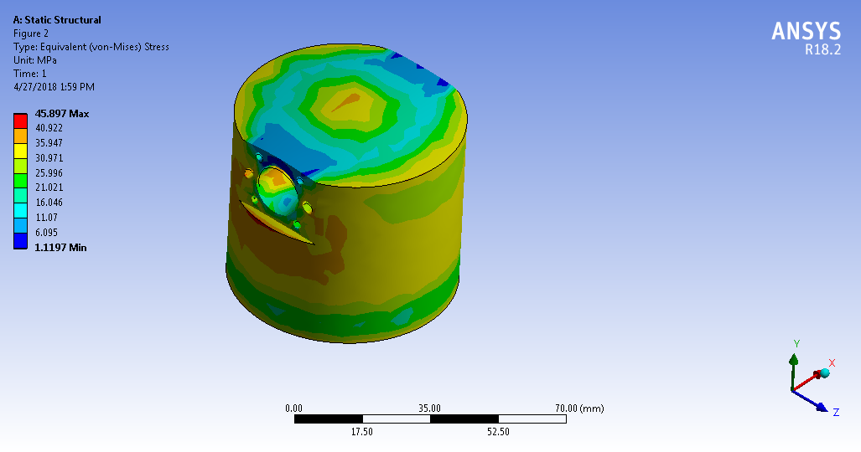
c) d)
Figure 19. FE Analysis of the Final End-Cap Printed by FDM-PA12: Failure Simulation after Application of Internal Burst Pressure, 55MPa

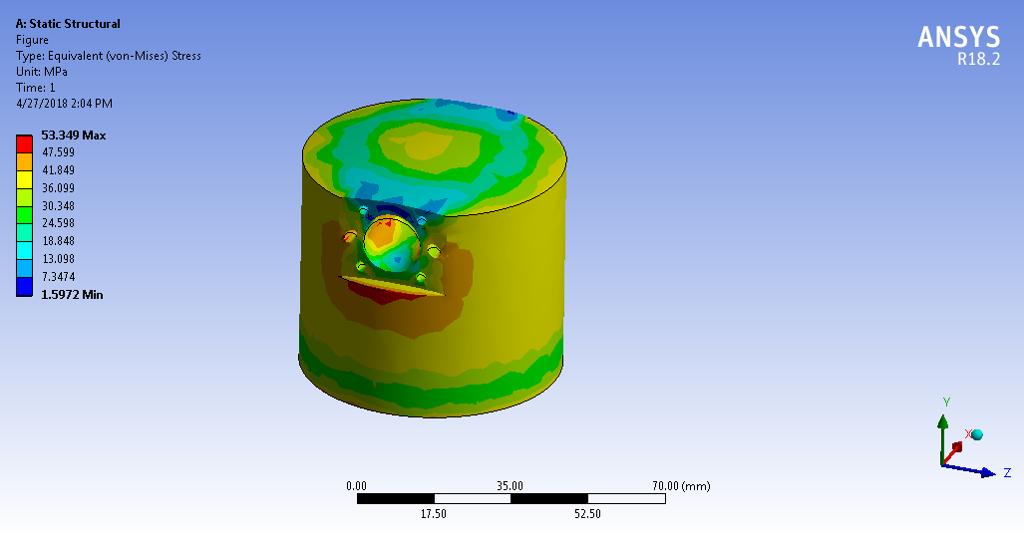
c) d)
Figure 20. FE Analysis of the Final End-Cap Printed by SLS-PA12: Failure Simulation after Application of Internal Burst Pressure, 65MPa

Design Rules

In addition to redesigning the integrated pressure reducer end-cap, we abstracted from the redesign experiences to identify lessons learned, design rules, and an overall design procedure. These lessons may be used in future projects in order to determine what problems occurred and how those problems handled and may be avoided. These rules are described in the text below and summarized in figures and tables.

4.1 Support Structure Removal from Internal Channels

Different types of polymer-based and metal 3d-printers are currently used as AM platforms to build several components/prototypes in both academic and industrial environments. In this project, the target AM process is chosen to be a polymer for the final product to be compatible with CPV. In spite of some advantages of polymer-based 3d-printing technology over the metal 3d-printing i.e., lower costs, lower weight products and less time consuming manufacturing process, it also has some limitations and imperfections that need to be addressed for redesigning and modification of systems and components. The 3D printer automatically generates support structures according to simple rules about down-facing surfaces. Typically, material jetting (e.g., Stratasys J750), material extrusion (e.g., Fortus 450mc, MarkForged), and metal powder bed fusion machines require support structures. In material jetting, supports are required for all down-facing surfaces to control droplet placement, while in material extrusion, a surface angle threshold of 45 degrees is typically applied that governs support generation. For small holes and channels, however, they are typically filled with support material, which must be removed to enable the holes and channels to achieve desired functionality.

Table.1. Design Rules for Support Structure

Rule#1 | Favorable | Unfavorable | Explanation
Inner Pipe Shapes |  |  | Support removal from channels: Polyjet, FDM. Channels should not be too small and long, or have sharp corners to enable support structure removal by dissolvable support material.
Overstay Effect at Solvent Bath |  |  | Dissolvable support structure removal duration: Polyjet, FDM. Parts should not spend too much time in the solvent bath for support structure removal. 2-3 hours maximum is recommended; otherwise, part material will be dissolved and small feature may disappear.

Both types of processes utilize support materials that can be dissolved in a solvent bath. It is important to realize that the solvent will dissolve part material as well, if given enough time. The design rules governing support structure for material jetting and deposition processes are: 1) channels should not be too small and long, and should not have sharp corners to enable the solvent to dissolve support material, 2) parts should be immersed in the solvent bath for only as long as needed for adequate support material removal to prevent damage to the part. These rules together with figure examples are shown in terms of favorable and unfavorable designs in Table 1.

4.2 Circular Features

In most 3D printing processes, feature cross-sections are most accurate when printed in the horizontal plane. For example, holes and circular bosses should be fabricated so their axes are vertical for best accuracy. The polymer powder bed fusion process is a notable exception, where horizontal axes are preferred. Features that are printed with horizontal or angled axes tend to suffer from shape errors, typically flattened somewhat. That is, a horizontal circular hole will have an elliptical cross-section, which is particularly prevalent in material extrusion processes. To correct this, the hole should be designed with an elliptical cross-section that is extended vertically. As obviously observed, Polyjet and SLS machines have created more desirable circular hole compared to FDM machine (see Figure 21).

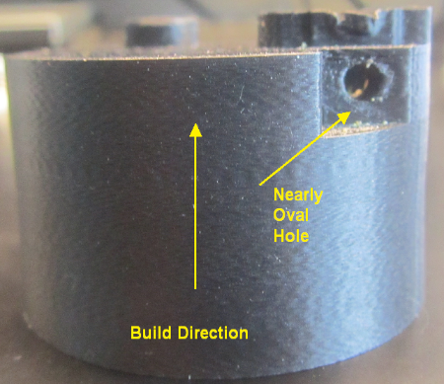

a) b) c)

Figure 21. Different Accuracy for Creating a Hole in the same Build Direction, a) FDM Machine, b) Polyjet Machine, c) SLS Machine
Unlike the circular cross section, machines show better performance to print the rectangular or generally squared cross sections.

4.3 Sealing Requirements

To achieve a successful end-cap design with integrated pressure reducer, it is necessary to ensure that leaks do not occur. Given that feature shape in 3D printed parts may not be accurate, special consideration is needed to prevent leaks by designing seals between some components. Of the most important considerations, cavity cross-section, surface roughness and material compatibility are highlighted. Figure 22 shows the example of improper gap between the O-ring and cavity.

Figure 22. Difference between Cavity and Holder Cross Sections

To illustrate a properly designed sealed joint, the interface between the poppet spring holder and end-cap cavity will be explained (see Figure 23 and Table 2). An O-ring will be used to ensure a good seal. To reduce the probability of air leakage, the depth of the groove in the holder is selected smaller than usual to accommodate the O-ring, meaning that the O-ring protrudes from the groove more than is typically for machined parts. In our designs, we used a 0.2mm clearance between the holder and cavity (0.4mm difference in diameters) and a 2mm O-ring. An interference fit of 0.1-0.2mm between the O-ring and cavity is recommended.

Figure 23. The Correct Tolerance between the Holder Diameter and the Wall of the Chamber to Support against Air Leakage (Dimensions in millimeter)
The assembly of pressure reducer components that are placed in both left and right chambers of the end-cap is shown in Figure 17. One can clearly see the O-rings in the slots of the poppet spring holder and the diaphragm.

Table.2. Design Rules for Sealing Requirements

Rule#3 | Favorable | Unfavorable | Explanation
Gap Between The O-ring and Cavity |  |  | Sealing of piston-cylinders: Polyjet. Use O-rings. Ensure that the O-ring protrudes 0.2-0.4 mm beyond typical practice to compensate for sag and surface roughness.

Conclusions

In this study, an initial configuration of the integrated pressure reducer end-cap was proposed as a working platform regarding the imperfections of the currently available pressure reducers in the market. Design procedure on the investigation of the advantages of AM technology was clearly defined in terms of the instructions and constraints which were collectively introduced as an entire framework of design for such devices. Considering the design constraints for the initial configuration proved that it cannot satisfactorily capture the criteria and constraints. Understanding the shortcoming of the initial design, the final configuration was proposed in order to meet the design criteria, constraints and thus describe the design methodology of an industrial example using AM technologies. Finally, the design rules and decision guides were abstracted from product in order to give a guideline to researchers and relevant industry sectors.

Acknowledgment
The author acknowledges funding from the Singapore National Additive Manufacturing Innovation Cluster (NAMIC) from grant 2016260. The author acknowledges usage of the Digital Manufacturing and Design Centre facilities at the Singapore University of Technology and Design. The author would also like to thank Prof. David William Rosen and Technical Staff at Composite Cluster Singapore Pte Ltd (CCS), namely Dr. Ethan Goh, Mr. Sufyian Sarwan and Dr. Florian Doetzer for their technical support during the project. The author would also like to thank all members of Sustainable Advanced Manufacturing (SAM) at the Sunderland Industry Center and Faculty of Technology at the University of Sunderland for providing a suitable environment to write this paper.

References
- V.Hassani, Z.Khabazi, H.A.Mehrabi, C.Gregg, R.W.O’Brien, Rationalization Algorithm for A Topologically-Optimized Multi-Branch Node for Manufacturing by Metal Printing, Journal of Building Engineering, 29 (2019).
- V. Hassani, Z. Khabazi, Form-Finding of the Metal 3D-Printed Node with Complex Geometry, LAMBERT Academic Publishing, Germany. ISBN 978-620-0-23681-4, (2019).
- J.P.Kruth, Material Increase Manufacturing by Rapid Prototyping Techniques, CIRP Annual Manufacturing Technology, 40(2) (1991) 603-614.
- J.P.Kruth, M.C. Leu, T.Nakagawa, Progress in Additive Manufacturing and Rapid Prototyping, CIRP Annual Manufacturing Technology, 47(2) (1998) 525-540.
- O.Cansizuglu, O.L.Harrysson, Applications of Structural Optimization in Direct Metal Fabrication, Journal of Rapid Prototyping, 14(2) (2008) 114-122.
- EnvisionTEC GmbH (2015) Audio in 3D:GN Resound. MK-CAS-GNResound-FN-V01.pdf (accessed 10.01.15).
- EnvisionTEC GmbH (2015) Highland Dental Laboratory Produces Crowns and Bridges with 3D Printer. http://envisiontec.com/envisiontec/wp-content/uploads/MK-CAS-HighlanDental-V01-FN-EN.pdf (accessed 10.01.15).
- EOS GmbH (2015) Alphform – Precision-Fit Cranial Implants Produced with Additive Manufacturing by EOS, http://www.eos.info/press/case_studies/download/medical_alphaform_canial_implant.pdf (accessed 10.01.15).
- J.Monguia, K.W.Dalgarno, J.Pallari,S.Cook, A Footprint: Ankle and Foot Orthotic Personalization via Rapid Manufacturing, Innovative Developments in Design and Manufacturing:Proceedings of the 5th International Conference on Advanced Research in Virtual and Rapid Prototyping, (2011).
- A.Aherwar, A.Singh, A.Pataik, A Review Paper on Rapid Prototyping and Rapid Tooling Techniques for Fabrication of Prosthetic Socket, High Value Manufacturing: Advanced Research in Virtual and Rapid Prototyping: Proceedings of the 6th International Conference on Advanced Research in Virtual and Rapid Prototyping, (2013).
- A.Aremu, I.Ashcraft, R.Hague, R.Wildman, C.Tuck, Suitability of SIMP and BESO Topology Optimization Algorithms for Additive Manufacture, 21st Annual SFF- An Additive Manufacturing Conference, Austin, TX, (2010).
- D.Brackett, I.Ashcraft, R.Hague, Topology Optimization for Additive Manufacturing, 22nd Proceedings of the SFF Symposium, Austin, TX, (2011).
- EOS GmbH (2015) EADS and EOS – Study Demonstrates Savings Potential for DMLS in the Aerospace Industry. http://www.eos.info/case_studies/download/aerospace_eads.pdf (accessed 10.01.15).
- M.Muir, Multidesciplinary Optimization of A Business Jet Main Exit Door Hinge for Production by Additive Manufacturing, Proceedings of the 8th UK Altair Technology Conference, (2013).
- M.Tomlin, J.Meyer, Topology Optimization of An Additive Layer Manufactured (ALM) Aerospace Part, Proceedings of the 7th Altair CAE Technology Conference, (2011).
- N.A.Meisel, M.R.Woods, T.W.Simpson, C.J.Dickman, Redesigning A Reaction Control Thruster for Metal-Based Additive Manufacturing: A Case Study in Design for Additive Manufacturing, Journal of Mechanical Design, 139(10) (2017).
- Wohler’s Report: 3D Printing and Additive Manufacturing State of the Industry, Annual Worldwide Progress Reprt, (2018).
- A.Wegner, G.Witt, Design for Laser Sintering, Journal of Plastics Technology, 3 (2012) 252-277.
- C.C.Seepersad, T.Govett, K.Kim, M.Lundin, D.Pinero, A Designer’s Guide for Dimensioning and Tolerancing SLS Parts, 23rd Annual International Solid Freeform Symposium, Austin, TX, available at:http://utwired.engr.utexas.edu/lff/symposium/proceedings Archive/pubs/Manuscripts/2012/2012-70-Seepersad, (2012).
- D.Thomas, The development of Design Rules for Selective Laser Melting, University of Wales, available at: http://hdl.handle.net/10369/913, (2013).
- C. Aumund-Kopp, F.Petzold, Laser Sintering of Parts with Complex Internal Structures, Proceedings of the 2008 World Congress on Powder Metallurgy and Particulate Materials, Washington DC, available at:www.rapidprototyping.fhg.de/content/pdf/t_08_aumund_Kopp_etal.pdf, (2008).
- N.Meisel, C.Williams, An Investigation of Key Design for Additive Manufacturing Constraints in Multimaterial Three-Dimensional Printing, Journal of Mechanical Design, 137(11) (2015).
- J.W.Booth, J.Alperovich, P.Chawla, J.Ma, T.N.Reid, K.Ramani, The Design for Additive Manufacturing Worksheet, Journal of Mechanical Design, 139(10) (2017).
- S. Yang, Y.F. Zhao, Additive Manufacturing-Enabled Design Theory and Methodology: A Critical Review, International Journal of Advanced Manufacturing Technology, 80 (2015) 327-342.
- J. Kranz, D. Herzog, C. Emmelmann, Design Guidelines for Laser Additive Manufacturing of Light Weight Structures in TiAl6V4, Journal of Laser Applications, 27 (S14001) (2015).
- P.Pradel, Z.Zhu, R.Bibb, J.Moultrie, A Framework for Mapping Design for Additive Manufacturing Knowledge for Industrial and Product Design, Journal of Engineering Design, 29 (2018) 291-326.
- P.M.Weaver, Designing Composite Structures: Lay-up Selection, In: Proceedings of the Institutions of Mechanical Engineers Part G Journal of Aerospace Engineering, 216 (2002) 105-116.
- M.K.Thompson, G.Moroni, T.Vaneker, G.Fadel, R.I.Campbell, I.Gibson, A.Bernard, J.Schulz, P.Graf, B.Ahuja, F.Martina, Design for Additive Manufacturing: Trends, Opportunities, Considerations and Constraints, 65 (2016) 737-760.
- B. Denkena, C. Schmidt, P. Weber, Automated Fiber Placement Head for Manufacturing of Innovative Aerospace Stiffening Structures, Journal of Procedia Manufacturing, 6 (2016) 96-104.
- L. Lin, L. Yong, W. Liwei, X. Jun, PMAC-Based Tracking Control System for 8-Axis Automated Tape-Laying Machine, Chinese Journal of Aeronautics, 22 (2009) 558-563.
- M.Leary, L.Merli, F.Torti, M.Mazur, M.Brandt, Optimal Topology for Additive Manufacturing: A Method for Enabling Additive Manufacture of Support-Free Optimal Structures, Journal of Materials and Design, 63 (2014) 678-690.

